Answers to Tutorial 1

Q1: Due to the strong symmetry in the picture, we interpret the 2 slanted lines in the image as arising from 2 parallel lines in the 3d world extending to infinity. Thus the upper horizontal line is interpreted as located at a further distance away than the lower horizontal line. Since the lengths of the 2 horizontal lines in the image are equal, it means that the actual 3d line corresponding to the upper line is longer. Thus, we perceive the upper edge as longer. This is known as the Ponzo illusion.

Q2. * (5, 8, –12) × (-3, 4, 2) = (64,26,44); ((1.45,0.59) in inhomogeneous coordinates)
* (2, 3, – 10) × (-4, - 6, 2) = (-54,36,0); this corresponds to a point at ∞ in inhomogeneous coordinates (interpretation: // lines in 2D space intersect at ∞)
* (5, -3, 1) × (-6, 12, 1) = (-15, -11, 42)
* (2, -9, 1) × (2, 10, 1) = (-19, 0, 38)

Q3. l_{H}

l₁ l₂

The intersection of l₁ and l₂ in the image plane corresponds to the infinitely distant points on the two parallel railway tracks in the 3d world. The points on the horizon can be interpreted as the union of all infinitely distant points along each direction (e.g. the dotted lines are the image of a railway track oriented in a different direction; they meet the horizon at a different point).

Note that l₁ and l₂ are representation of lines in P². These image lines are not parallel but they correspond to the projection of 2 parallel lines in 3D space (this also means that projection does not preserve parallelism). Note: I do not expect you to know how to represent lines in P³.

Q4. 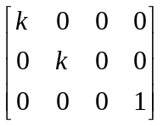

Q5. (a)
- x=A⁺ b = 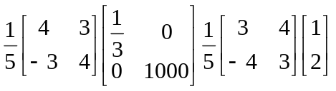
(ii) x=A⁺ b = 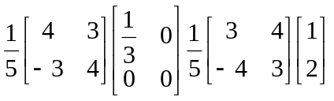
This is the solution such that ||x|| is minimum norm, but it may not have any physical meaning, depending on the problem that you are solving. We will see one such example in the chapter on motion.

(b) x = last column vector of V = (3/5, 4/5)
Note U & V are both orthogonal matrices, ie. each row and column of U & V must be a unit vector. Thus, you must put the two 1/5 back into U & V.

Q6. (X,Y,Z,0); (1,0,0,0); (1.5,2,1)

Q7: l^{T} x = 0
l^{T} PX = 0
(P^{T} l)^{T} X= 0
This corresponds to an equation of plane n^{T}X=0.
∴ P^{T} l is the representation of a plane in 3d space. This means that the object point X that project to points on the line l must lie on a plane whose normal is given by P^{T} l. (this is a plane that contains line l and the camera center)

Q8. Shape cues come from these sources:
- Shading (bushes, though somewhat subdued due to the fog) tells us the orientation of surfaces.
- Texture (bridge) tells us the orientation of surfaces.
- Line drawing or perspectives (sides of bridge, house, wooden posts) tells us the orientation of surfaces.
- Occlusion (bushes and post occluding the house) tells us the depth order of objects

Also, distant objects are more faded compared to near objects due to the fog, thus furnishing another source of depth cue.

